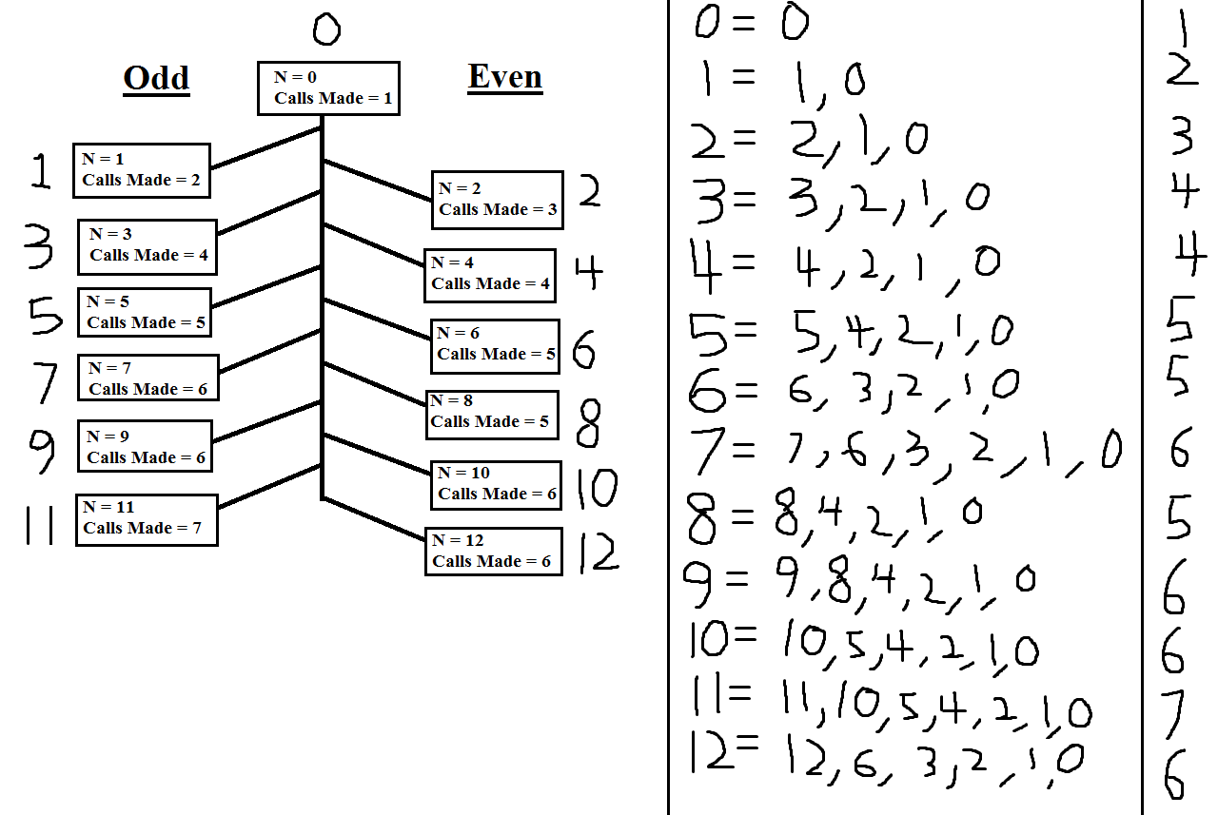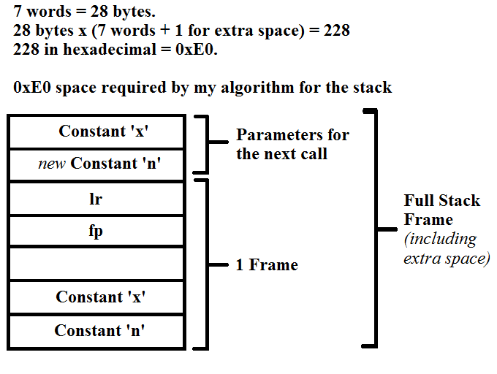

**Assignment Question - Answered**

**Single Full Stack Frame**

**Assignment Question - Answer**